Task 17

Q1.

Open the Chrome Browser .

Launch the url <https://demoblaze.com/index.html#> .

Choose Laptops section .

Select the first Laptop.

Click the Add Cart button.

Script:

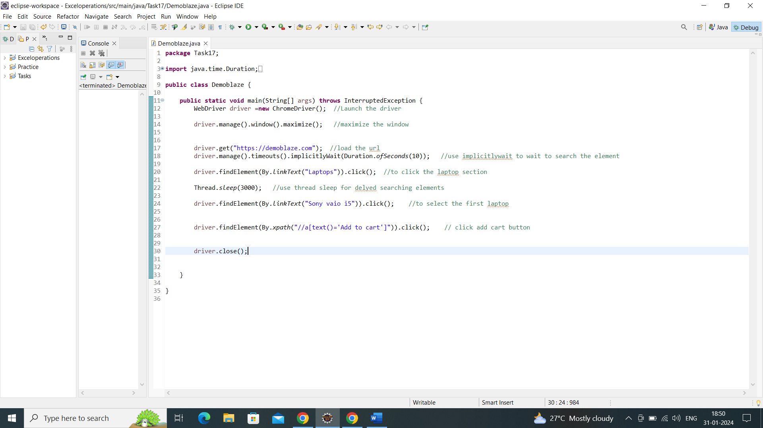

Output:

